https://www.jdoodle.com/embed/v0/5U1S

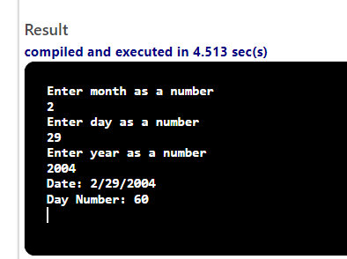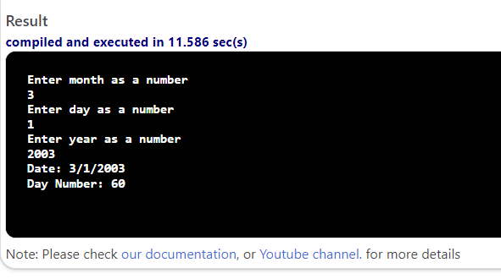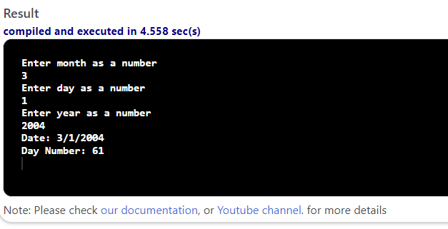

#include <iostream>

using namespace std;

int main()
{
int day, month, year;
cout << "Enter month as a number" << endl;
cin >> month;
cout << "Enter day as a number" << endl;
cin >> day;
cout << "Enter year as a number" << endl;
cin >> year;
bool leapyear;
leapyear = false;
if ((year % 4) == 0)
{
leapyear = true;
}
int dayNum;
switch (month) {
case 1:
dayNum = day;
break;

case 2:
dayNum = day + 31;
break;

case 3:
dayNum = day + 31 + 28;
break;

case 4:
dayNum = day + 31 + 28 + 31;
break;

case 5:
dayNum = day + 31 + 28 + 31 + 30;
break;

case 6:
dayNum = day + 31 + 28 + 31+ 30 + 31;
break;

case 7:
dayNum = day + 31 + 28 + 31+ 30 + 31 + 30;
break;

case 8:
dayNum = day + 31 + 28 + 31+ 30 + 31 + 30 + 31;
break;

case 9:
dayNum = day + 31 + 28 + 31+ 30 + 31 + 30 + 31 + 31;
break;

case 10:
dayNum = day + 31 + 28 + 31+ 30 + 31 + 30 + 31 + 31 + 30;
break;

case 11:
dayNum = day + 31 + 28 + 31+ 30 + 31 + 30 + 31 + 31 + 30 + 31;
break;

case 12:
dayNum = day + 31 + 28 + 31+ 30 + 31 + 30 + 31 + 31 + 30 + 31 + 30;
break;

case 13:
dayNum = day + 31 + 28 + 31+ 30 + 31 + 30 + 31 + 31 + 30 + 31 + 30 + 31;
break;

default:
cout << "Invalid month entered." << endl;
break;
}

if (leapyear==true && month > 2)
dayNum ++;

cout << "Date: " <<month<<"/"<<day<<"/"<<year <<endl;
cout<<"Day Number: "<<dayNum<<endl;

return 0;
}

